The makers of java made the final keyword multipurpose

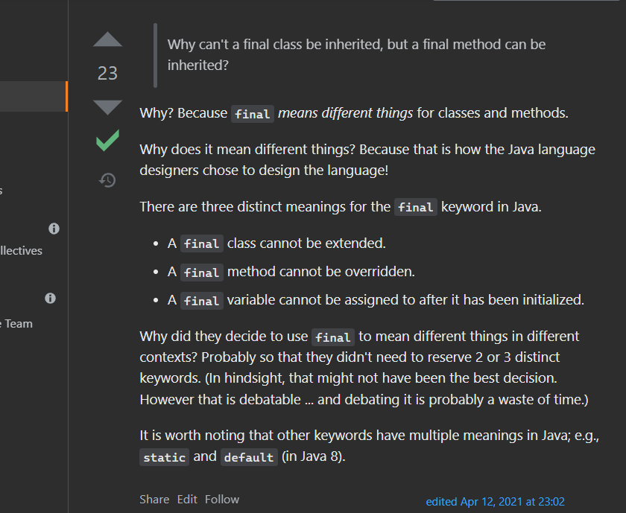

A final class can not be inherited

How to prevent inheritance of a class ?

We can use the final keyword

A final method inside the parent class can not be overridden

When we make a class final then implicitely all the methods

inside that class also becomes final

Now why final method can not be overridden, that might be asked in interview, that is related to maybe runtime, compile time polymorphism ?